**EyeSim VR**

**User’s Manual**

EyeSim VR Team

November 3, 2017

1. **GENERAL INFORMATION**

This simulator will let users simulate the robots’ execution of functions specified in RoBIOS-7 file. It accepts and runs customized script files written in C, and simulates robot behaviors of each command. User can select or specify a world or maze file for the simulator to build the simulation environment accordingly. User can also create any number of robots of any kind provided in the robot models, and the robot added last will be controlled by the user script. Objects like cans and soccer balls can also be added to the simulation, and physical interactions between these objects and robots can also be simulated.

1. **SYSTEM CONFIGURATION**

Following is a table of tested OS and prerequisites for each OS. Please note that other system versions may also work, they are just not tested yet, if your system version can not work properly, please file a bug according to section 5 or upgrade your system to the tested version.

The required supporting software should be installed in their default directory before start using the simulator.

|  |  |  |
| --- | --- | --- |
| **Operating Systems** | **OS Version** | **Prerequisites** |
| Windows | Windows 8.1, 10 | None |
| Mac OS | 10.10.X | Install Xcode and Xquartz |
| Linux | 64bit | Install X11 library |

1. **GETTING STARTED**
   1. **Installation**

For Mac OS:

1. If you have never installed Xcode before, you should download and install Xcode from apple store via the following link:

<https://itunes.apple.com/au/app/xcode/id497799835?mt=12>

1. If you have never installed Xquartz before (please see Note 1), you should download and install Xquartz via following link: <https://www.xquartz.org/>
2. Open your terminal and type in following command to create a symbolic link of X11 library, your password is required to make it work:

**sudo ln -s /opt/X11/include/X11 /usr/local/include/X11**

1. Download the EyeSimVR-Mac.zip file from the following link:

<http://robotics.ee.uwa.edu.au/eyesim/ftp/EyeSim-0.7.pkg>. This is a pkg installation file, if you have installed previous versions of simulator, please delete the whole **eyesim** folder before install this new version. You can follow the instructions to install this version, it will automatically create an **EyeSim** folderin your **Applications** directory.

1. You can lauch the application called **EyeSim** from your Lauchpad to start the simulator.

**Note 1:** You may find that by default you already have Xquartz installed among your applications, but you still need to download and install Xquarts again using the link provided in step 2, because the default Xquartz doesn't include X11 which will be required to run simulation.

**Note 2**: If you OS pops up a warning window showing that Xquartz can’t be opened because it is not downloaded from Apple Store, it’s needed to go to ***System Preferences***-> ***Security & Privacy***, then click on the lock icon at the bottom left corner to unlock it, you may need to input password to do that, and then at the ***Allow apps downloaded from:*** section, select ***App Store and identified developers***.

**Note 3**: The OS may pop up a window of warnings about untrusted developer, in such case, it’s needed to go to ***System Preferences***-> ***Security & Privacy***, and then click ***open anyway*** at the lower part of the window to confirm launching of the application.

For Windows:

1. If you have already downloaded and installed simulator before, please uninstall the the simulator before proceeding:
2. Download latest EyeSim-Windows-07.exe file from the following link:

<http://robotics.ee.uwa.edu.au/eyesim/ftp/EyeSim-Windows-0.7.exe>

1. Double click to install installer to install the simulator, related files will be installed in the C:\programs(x86)\EyeSim directory

For Linux:

1. Install X11 library using following command:

***sudo apt-get install libx11-dev***

1. Download latest EyeSimVR-Linux64.zip file from the following link:

<http://robotics.ee.uwa.edu.au/eyesim/ftp/EyeSimVR-Linux64.zip>

Unzip the file to get a folder called **eyesim**, then place this folder at your desired loacation.

* 1. **System Menu**

When the application is launched, a window as shown in figure 3-1 will show up to let you select the resolution and graphics quality, and if ***windowed*** check box is ticked, the simulator will run in a window instead of full screen, you can view the keybinds for control the simulator by choosing the **input** tab.

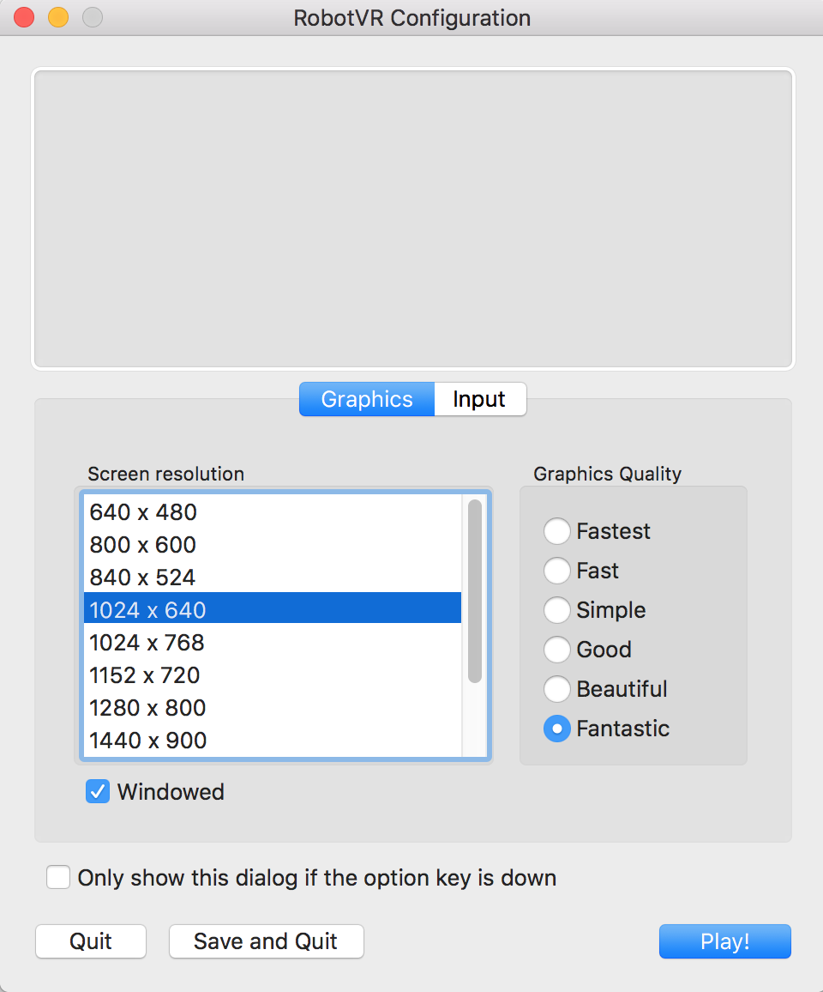

**Figure 3-1** Configuration window for Mac

The simulator main window shows after the ***Play!*** button is clicked, as shown in figure 3-2. The black plane in the middle is where the simulation will be, and the menus on the upper-left corner help to set up the simulation.

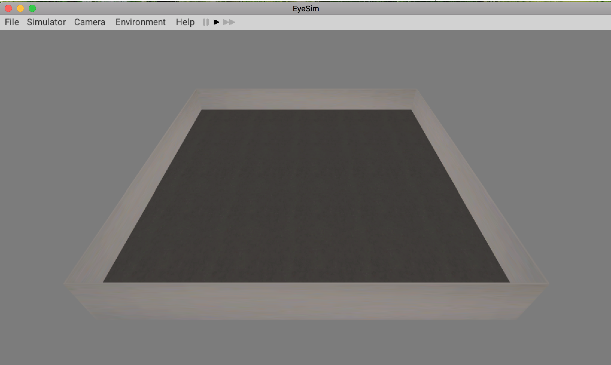

**Figure 3-2** Simulator main window

|  |  |  |  |  |
| --- | --- | --- | --- | --- |
| File | Simulator | Camera | Environment | Help |
| Open Terminal | Add Robot | Birdseye View | Add Wall | RoBIOS API |
| Load Sim | Add Object | Reset Camera | Remove Wall | View Log |
| Save Sim | Add Marker |  |  | About |
| Load World | View Robots |  |  |  |
| Save World | View Objects |  |  |  |
| Create World | Save State |  |  |  |
| Reset World | Load State |  |  |  |
| Load Object | Pause |  |  |  |
| Settings | Resume |  |  |  |
| Exit |  |  |  |  |

Table 3-1

This above table shows the menu functions of simulator, we can load world, save world, add objects and robots using these menus, detailed information related to each of the menu item will be introduced later.

1. **USING THE SYSTEM**

Please make sure you have all the required files/folders as described in section 3.1 before you proceed. Please make sure you launch the simulator application to perform following supported functionalities.

* 1. **Adjust the Viewpoint**

To adjust the simulation plane to a better viewpoint, you can use →←↑↓ arrow keys and **w, s, a, d** to move the plane around, and use the number key x and z to zoom in and out.

You can have a birdseye view of the simulation by choose from menu **Camera** -> **Birdseye View**. And you can reset the camera to normal viewpoint by **Camera** -> **Reset Camera**.

* 1. **Load/Reset/Save/Create World**

To save the current world, select **File -> Save World**, simulator will save current world settings in a file called **SavedWorld.wld** in the root of the EyeSim folder.

To load a world/maze file as simulation environment, in the main simulator window, select ***File***-> ***Load World*** submenu and then in the popped-up file selector, navigate to and click on the intended world or maze file (with wld or maz extension). The simulator will build simulation environment according to the selected file.

To reset the world/maze environment to the default one, select ***File***-> ***Reset World*** submenu.

You can use the **File -> Create** World menu to adjust the dimensions of the current world.

* 1. **Add/Remove Wall**

To manually create a customized world, you can select **Environment** -> **Add Wall** to add wall, then you need to click two points in the simulator plane to set the starting point and ending point of the wall.

To remove any wall, you can choose **Environment** -> **Remove Wall**, and then click on the wall to be removed from environment, the selected wall will turn red when you move cursor on to it indicating it has been selected.

* 1. **Place Robots/Objects/Markers**

To place a robot in the simulator, select ***Simulator***-> ***Add Robot*** then selection a robot to add to the simulation.

To place an object (a can or a soccer ball) in the simulator, select ***Simulator***-> ***Add Object*** , then select the kind of object you want to put in the simulation.

Then you can move the cursor with the robot/object stuck on it to any valid place (robot/object is highlighted in green to indicate a valid placement spot, while in red not valid), and click your mouse to place it.

Though ***Simulator***-> ***Add Marker***, you can add a colored marker point to the world in order to mark a position. You can also select a different color after the marker is placed, by double clicking on it and choose a color in the pop up inspector.

* 1. **Inspect Robots/Objects/Markers**

User can inspect the current status of any robot/object by double clicking on it, an inspector window will pop up.

**The robot inspector window:**

Figure 4-1 shows the inspector window of an object.

The **Camera** tab provides a camera image, and you can control the level of noise added to the image, by selecting **Salt and Pepper** and adjust the two parameters below.

The **PSD** tab shows the current psd readings of the robot, and you can also add errors to the PSD sensors by selecting **Error Enabled** and adjust the parameters of mean and std. Dev. of error. There's a toggle box called **Visualize Sensor**, when it is toggled, simulator will show the PSD sensor ray cast when performing the **PSDGet** command.

The **Driving** tab shows the current x,y coordinates of the robot and the rotation value Phi.

The **Control** tab can be used to select compiled simulation script files for simulation, and disconnect the control at any time.

**The object inspector window:**

Figure 4-2 shows the inspector window of an object, the information includes the name, id of the inspected object, x and y coordinates of the object against the lower-left corner of the simulation plane, and the rotation parameter.

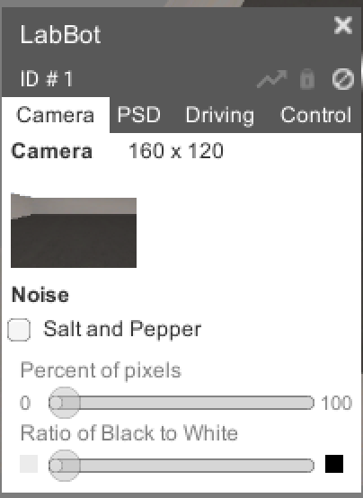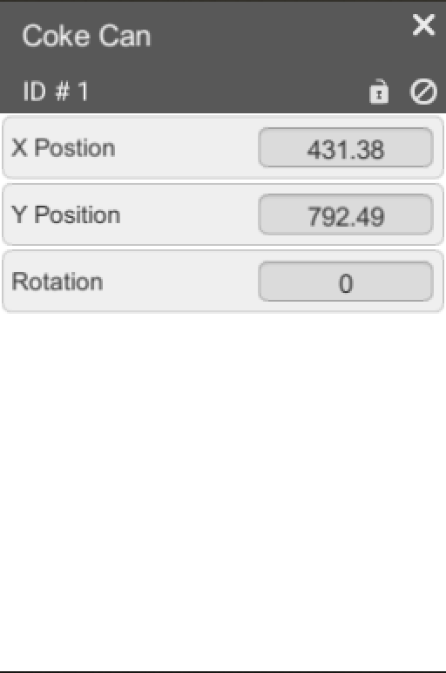**Figure 4-1** Inspector window **Figure 4-2** Inspector window

for robots for objects

* 1. **Relocate/Rotate a Robot/Object/Marker**

You can move a robot, object or marker to any new valid spot after they have been added to the simulation.

To move a robot/object, you can double click on the target to open the inspector window, then click on the Screen%20Shot%202017-08-12%20at%202.18.15%20PM.pngicon so it becomes grey, a marker doesn't require this setting to move.

If you want to move the robot/object/marker, you can click on the target and drag your cursor to the desired spot, then click again to place it.

If you want to rotate the robot/object, you click on the target and drag until it is picked up and turned green, then use **-** and **=** key to control its rotation.

* 1. **Relocate/Rotate a Robot/Object/Marker to Specified Value**

Sometimes you want to move a robot/object/Marker to a specified position or rotate a robot/object to a specified degree.

To specify the x,y position or rotation degree of a robot/object/marker, you need to select submenu ***Simulator***->***Pause*** to make the position or rotation data editable, then double click on the target to open inspector window, you can see now you can input or change the position and rotation value of the target, after you typed in each desired value, you need to click elsewhere to make it work, after finishing the relocation, you should select ***Simulator***->***Resume*** to return to normal mode.

* 1. **View all Robots/Objects**

You can inspect all robots/objects in the simulation easier by selecting ***Simulator-> View Robots/View Objects*** submenu, this will create a list of all the robots/objects in the simulation as shown in figure 4-3. You can inspect the current status of any robot/object by simply clicking on the target in the list, and an inspector window of that target will pop up.

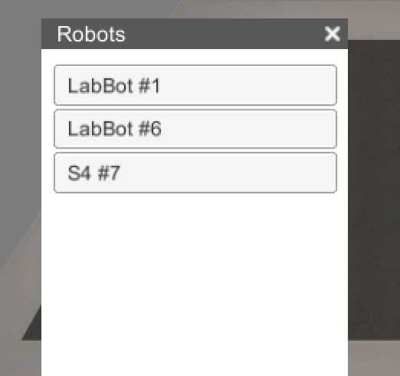

Figure 4-3 list of robots

* 1. **Delete a Robot/Object/Marker**

You can delete any robot/object/marker in the simulation by double clicking on the target to open the inspector window, then click the Screen%20Shot%202017-08-12%20at%203.08.01%20PM.png icon to remove the target from the simulation.

* 1. **Save Sim/Load Sim/Save State/Load State**

During the process of your simulation, you may want to save the whole current simulation including the world, robots, objects and markers, you can select **File** -> **Save Sim**, simulator will automatically save the current simulation to a file called **SavedSim.sim**. You can restore the simulation at a later time by using **File** -> **Load Sim**, and select the SavedSim.sim file. Alternately, you can use **Similator** -> **Save State**, and **Simulator** -> **Load State** to quickly store and restore the simulation, without having to save and fetch from a sim file.

* 1. **Create & compile scripts**

To compile example scripts, go the subfolders under example folder, where you can find a file called **Makefile** together with other script files in C, type following command in your terminal to compile all the scripts in this folder:

**make**

You will find one compiled file generated (in .x or .exe extension ) for each script file.

To compile your own script file,

For Mac OS:

To compile your own script file You can create a folder called "myscripts" in eyesim folder. Then created a script file in C in this folder (for e.g. main.c).

Open your mac terminal and cd to this folder. Type in following command to compile the script files in this folder, you can also lauch a terminal window using **File** -> **Terminal** :

**gccsim -o program main.c**

The above command will generate an executable file called program in this folder.

For Windows:

Create a folder called **myscripts** at any place you want, and create a script file called main.c inside it.

In simulator main window, select submenu ***File/Open Terminal*** , and the Cygwin terminal will pop up.

You can see your current folder is called **tmp** under Cygwin folder, you can navigate to your c disk using command:

**cd /cygdrive/c**

Then further navigate to your **myscripts** folder, and run command.

**gccsim -o program main.c**

Advanced Windows Users (experience with cygwin / linux subsystem):

If you have an installed version of cygwin already on your machine, or are experienced using the Linux subsystem for Windows, you can use either of these to run your programs. The eyesim libraries and header files are available by themselves.

For Linux:

To compile your own script file You can create a folder called "myscripts" in eyesim folder. Then created a script file in C in this folder (for e.g. main.c).

Open your terminal and cd to this folder. Type in following command to compile the script files in this folder:

**gcc main.c - L ../lib -I ../include -leyesim -lX11 -lm -o program**

The above command will generate an executable file called **program** in this folder.

**Note 1**: Appendix A shows a list of RoBIOS-7 functions that are not supported by the simulator, all other functions in RoBIOS-7 should work in the script.

**Note 2**: Following is a very simple sample script for your reference.

#include <stdio.h>

#include "eyebot.h"

int main() {

VWStraight(600, 30);

VWWait();

VWTurn(180,10);

}

* 1. **Start Simulation**

**Requirements:**

There should be at least one robot in the simulation, if not, you should add a new robot to the simulation according to section 4.3.

There should be a compiled script file (with extension **.x**)placed in the folder, if not, you should first create a script file and have it compiled according to section 4.9.

There are two ways to control a robot with script.

**From command line:**

For Mac OS/Linux:

Open terminal and navigate the folder of any executable files you have compiled and run command: **./{your file name}** to run the executable script.

For Windows:

Open the cygwin terminal and navigate (cd) to the directory where the executable file (program.exe) is located , then run: **./program** in terminal.

A response in the terminal as shown in figure 4-4 is expected to show, indicating the simulation is running, and you can watch the simulation in the application.

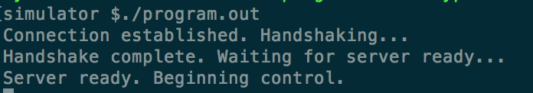

Figure 4-4 terminal response

**Note**: Currently only one robot can be controlled by the script, if you have multiple robots added to the simulation plane, only the last added robot will respond to the script.

**Select control script from robot inspector window:**

By selecting control script for each robot in the simulation, we can control multiple robots at the same time. Double click on any robot in the simulation, the inspector window will show up (as shown in figure 4-1). Click on the ***Select Control*** button, than navigate and select any compiled script file (in .x extension), the robot will simulation the selected script. To terminate the execution of the rest script commands, just lick on ***Disconnect*** button in the inspector.

* 1. **Pause/Resume/Speed up Simulation**

You can pause and resume a simulation when the simulation is running, by select ***Simulator***->***Pause*** to pause the current simulation, and ***Simulator***->***Resume*** to resume the simulation. You can also click on the icons on menu bar :../../../../../Desktop/Screen%20Shot%202017-09-14%20at%2010.30.37%2 to pause, resume and speed up the simulation.

* 1. **Add Trace to Robot**

You can add trace to the robot during a simulation by double clicking on the target robot to show the inspector window, then click on the  icon on the upper right corner of the inspector window to may it highlighted instead of grey, you will see a green trace added to the route it has covered.

1. **LOADING FILES**

EyeSim supports the loading of the following external files:

* .robi files for custom Robots
* .esObj files for custom Objects
* .wld or .maz files for custom environments
* .sim files for preconfigured simulations

These files are standard text documents, with the appropriate extensions, and contain a series of commands to pass to the simulator. Each command begins with a keyword, as is followed by arguments separated by whitespace. An argument can be contained by double quotes (“”) if it contains a whitespace itself (such as a path to a file).

* 1. **.robi Files**

A .robi file specifies the parameters for a custom robot. Any line that begins with a # is treated as a comment, and is not processed by EyeSim. The keywords and corresponding arguments are as follows:

|  |  |
| --- | --- |
| **Keyword** | **Arguments Specification**  **Example** |
| drive | One of the following:  DIFFERENTIAL_DRIVE  ACKERMANN_DRIVE  OMNI_DRIVE |
| name | Name of the robot  MyRobot |
| mass | Mass in kg, followed by position centre of mass in mm (kg x y z)  5 0 30 -50 |
| speed | Maximum linear velocity in mm/s  600 |
| turn | Maximum rotational velocity in deg/s  300 |
| model | Path to a .obj model, x y z offset (in mm), rotation about x y z axis (in degrees)  “\Robots\Models\LabBot.obj” 14 0 0 0 90 0 |
| axis | Distance between the centre of the robot, and the centre of the axis (vertical, horizontal in mm)  22.7 10.8 |
| psd | Psd name, id number, position relative to robots centre x y z (in mm), and rotation about vertical axis (in deg)  PSD_LEFT 1 30 0 80 90 |
| camera | Camera position relative to robot x y z (in mm), default pan and tilt (in deg), max pan and tilt (in deg)  40 50 70 0 0 90 90 |
| wheel | Wheel diameter (in mm), maximum rotational velocity (in deg/s), encoder ticks per revolution, distance between wheels (track, in mm)  45 3600 540 70 |
| lidar | Number of LIDAR points, angle relative to driving plane (in deg, between -90 and 90)  360 0 |

The first non-comment line of a .robi file must be the drive keyword and arguments. After a robot is loaded, it will be added to the Add Robot submenu (under Simulator), specified by the name parameter.

* 1. **.esObj files**

Custom objects can be loaded with .esObj files. These are simple world objects that interact physically with the robots. The keywords for this type of file is as follows:

|  |  |
| --- | --- |
| **Keyword** | **Arguments Specification**  **Example** |
| obj | Path to a .obj file  “\Objects\Models\Bottle.obj” |
| scale | Scale of the object (modifies model size, positive number)  0.1 |
| mass | Mass (in kg), centre of mass x y z (in mm)  1 0 0 0 |
| capsule | Centre of capsule x y z (in mm), radius (in mm), height (in mm), vertical axis (character x, y, or z)  0 0 0 1 3 y |
| sphere | Centre of sphere x y z (in mm), radius (in mm)  0 0 0 1 |
| box | Centre of box x y z (in mm) side length of box x y z (in mm)  0 0 0 2 2 2 |

An object consists of multiple colliders, to allow more complicated objects to be created. All the positions are relative to the centre of the model.

* 1. **.wld and .maz files**

Custom environments can be loaded with .wld and .maz files. A .wld file consists of a floor, walls, and an optional floor texture. The floor can be specified by the keyword floor followed by the width and height in mm:

floor 2000 2000

Or by the width and height keywords

width 2000

height 2000

A texture to apply to the floor is specified by the keyword floor_texture, followed by a path to a .png file.

Walls have no keyword, and are simply lines with 4 numbers: x1 y1 x2 y2 eg:

0 0 1000 1000

Will create a diagonal wall from (0, 0) to (1000,1000).

Maze files, specified by .maz, contain an ASCII representation of what the maze looks like, using the characters | and _, with the very last line being the wall size in mm. An example of a maze:

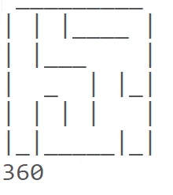

* 1. **.sim files**

A sim file is used to store configurations, for quickly repeating experiments, by setting up the environment and objects. A sim file can consist of the following keywords:

|  |  |
| --- | --- |
| **Keyword** | **Arguments Specification**  **Example** |
| world | Path to a .wld or .maz file  “\Worlds\MyWorld.wld” |
| robi | Path to a .robi file  “\Robots\MyRobot.robi” |
| obj | Path to an .esObj file  “\Objects\MyObject.esObj” |
| object_name | Name of an actual object, position x y (in mm) rotation phi (in deg), path to executable (if a robot)  labbot 1000 1000 0 “\Programs\Drive.x”  can 1500 1500 0 |
| marker | Position of marker x y (in mm), color of marker r g b (0 to 255)  1000 1000 255 0 255 |

Note that for object_name, the keyword is the name of the object itself (ie labbot, s4, can, etc.) This can also be the name of a robot or object that has been loaded previously with the robi or obj keywords.

1. **BUG REPORTING**

If you have detected any bug or considered any function missing or needed to be improved while using this EyeSim-VR simulator, you are highly encouraged to report the bug or suggestion to us for further corrections and improvements.

We are using Bugzilla as an online bug-reporting system, you will see the main page of Bugzilla as shown in figure 5-1 by accessing following link: <http://robotics.ee.uwa.edu.au/bugzilla/>.

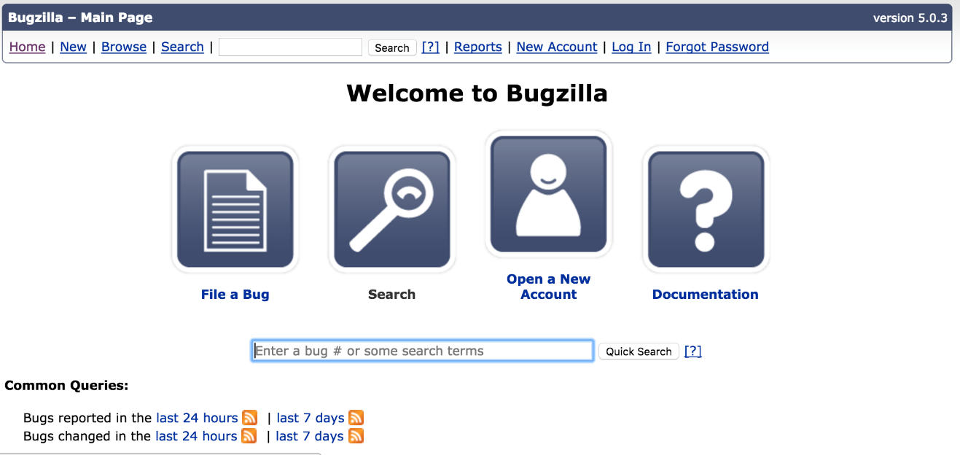

Figure 5-1

* 1. **Create an Account/login**

**Create account**

If it is the first time you are using this system, you should open a new account by clicking on the ***Open a New Account*** icon, then follow the steps to create your account. (note: sometimes it may take a few minutes for Bugzilla to send the registration email, please be patient). you will automatically get logged in after you have created your account.

**Log in**

You can log in directly if you have an account through the ***LogIn*** menu.

* 1. **File a Bug**

After logging in, you can click the File a Bug icon to report a bug. Then after clicking on [**Robot-VR**](http://robotics.ee.uwa.edu.au/cgi-bin/bugzilla/enter_bug.cgi?product=Robot-VR) as selected product, you will see a report form as shown in figure 5-2. Please select the specific component that is related to the bug, and **Severity** of the bug, **Hardware type** of the computer you are using and the **OS**.

In the **Summary** section, you are supposed to write a succinct sentence summarizing the bug.

In the **Description** section, the details of the bug, like when it occu4rs, what is the setup of environment, what are the previous actions you have performed, what you suspect has led to the bug should be presented.

In the **Attachment** section, you can add attachment like a snapshot of the bug, the error message or some other supporting files. Then you can click on Submit Bug button to submit the bug report.

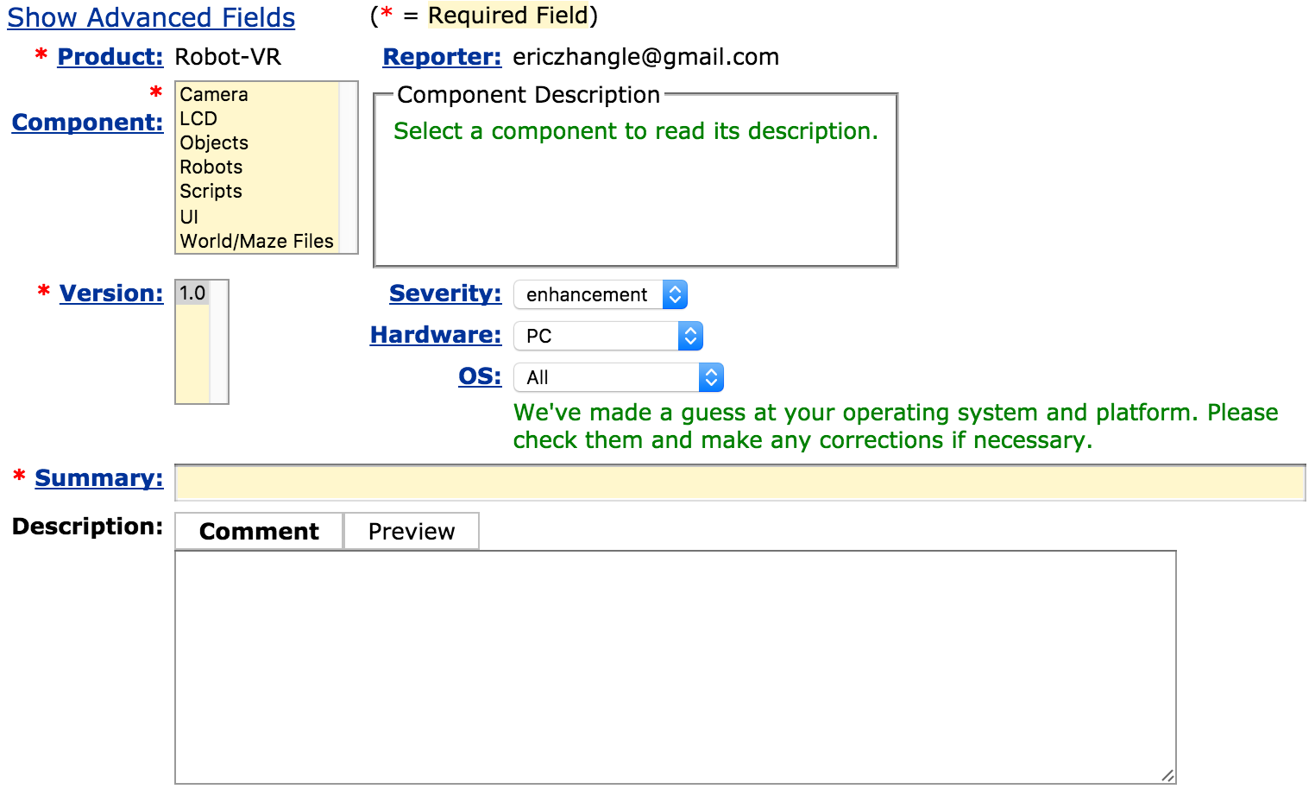

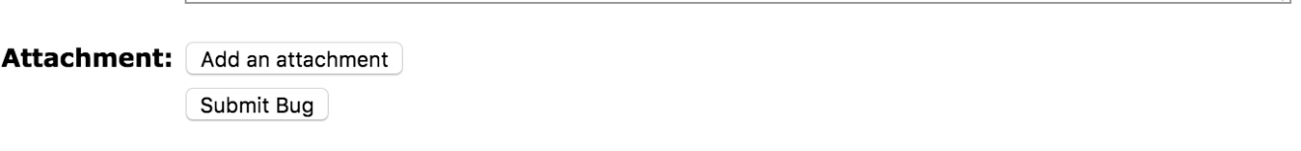

**Figure 5-2** Bug report form

**Appendix A**

**RoBIOS-7 Functions Not Supported List**

## Servos and Motors (2 of the functions in RoBIOS-7)

int ENCODERRead(int quad); // Read quadrature encoder [1..4]

int ENCODERReset(int quad); // Set encoder value to 0 [1..4]

**USB/Serial Communication** (all functions in RoBIOS-7)

int SERInit(int interface, int baud,int handshake); // Init communication (see parameters below), interface number as in HDT file

int SERSendChar(int interface, char ch); // Send single character

int SERSend(int interface, char *buf); // Send string (Null terminated)

char SERReceiveChar(int interface); // Receive single character

int SERReceive(int interface, char *buf, int size); // Receive String (Null terminated), returns number of chars received

bool SERCheck(int interface); // Non-blocking check if character is waiting

int SERFlush(int interface); // Flush interface buffers

int SERClose(int interface); // Close Interface

## Digital and Analog Input/Output (all functions in RoBIOS-7)

int DIGITALSetup(int io, char direction); // Set IO line [1..16] to i-n/o-ut/I-n pull-up/J-n pull-down

int DIGITALRead(int io); // Read and return individual input line [1..16]

int DIGITALReadAll(void); // Read and return all 16 io lines

int DIGITALWrite(int io, int state); // Write individual output [1..16] to 0 or 1

int ANALOGRead(int channel); // Read analog channel [1..8]

int ANALOGVoltage(void); // Read analog supply voltage in [0.01 Volt]

int ANALOGRecord(int channel, int iterations); // Record analog data (e.g. 8 for microphone) at 1kHz (non-blocking)

int ANALOGTransfer(BYTE* buffer); // Transfer previously recorded data; returns number of bytes

## IR Remote Control (all functions in Robios-7)

int IRTVGet(void); // Blocking read of IRTV command

int IRTVRead(void); // Non-blocking read, return 0 if nothing

int IRTVFlush(void); // Empty IRTV buffers

int IRTVGetStatus(void); // Checks to see if IRTV is activated (1) or off (0)